M LITE 1/26/2015
M LITE FC System
Quick start manual

Ver.0.7.0
M LITE is a trademark of 3dpmav
www.3dpmav.com
- 1 -

33dpamv
M LITE 1/26/2015
WARNING

M LITE is a remarkable performance multi-rotor flight controls. To give user a perfect control experience.
Model aircraft classified as non-toys, novice please under the guidance of senior model players use this product. Keep away from children, crowds and sensitive buildings in flight. Do not install the propeller to avoid accidents during installing the commissioning and firmware upgrades. The use of this product caused by direct or indirect loss and injury, Eckert Aerospace Technology Co., Ltd. is not responsible.

www.3dpmav.com
- 2 -

M LITE 1/26/2015
www.3dpmav.com
- 3 -
Product introduction
M LITE is a lightweight multi-rotor flight controller designed specifically for aerial and FPV flight.
Support +4, X4, +6, X6, Y6, five different racks. Currently only supports the normal PWM receiver.
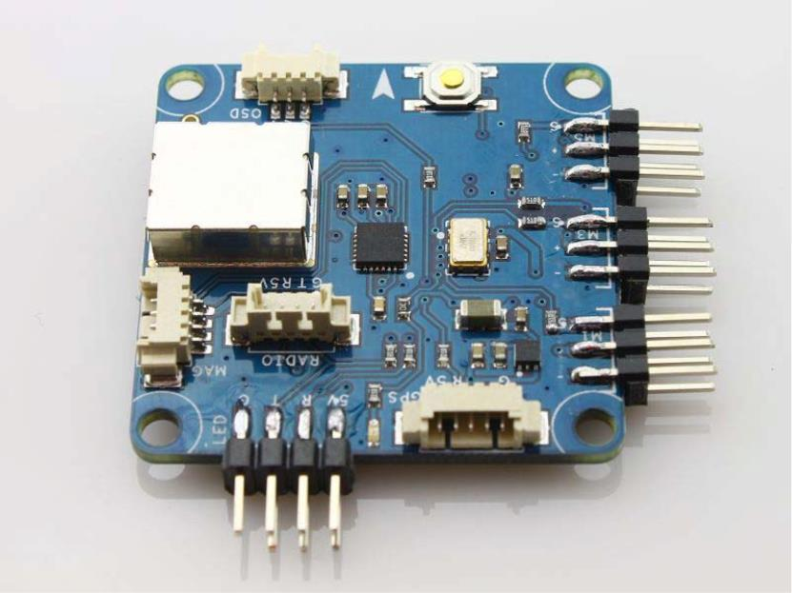

Product architecture
Master controller

M LITE 1/26/2015

www.3dpmav.com
- 4 -
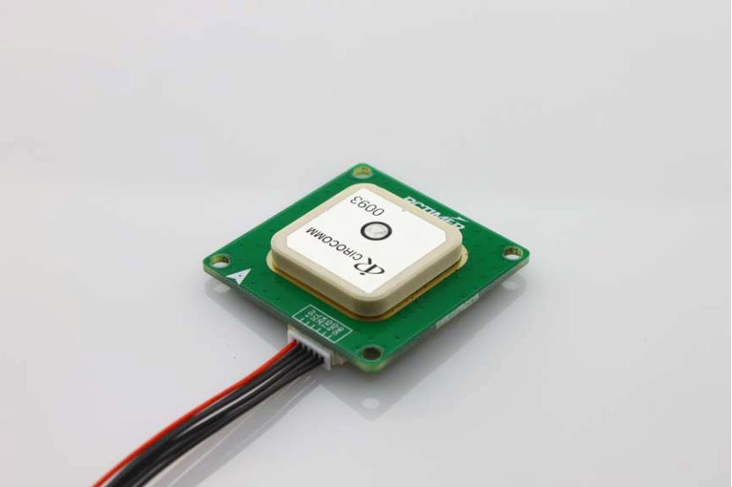
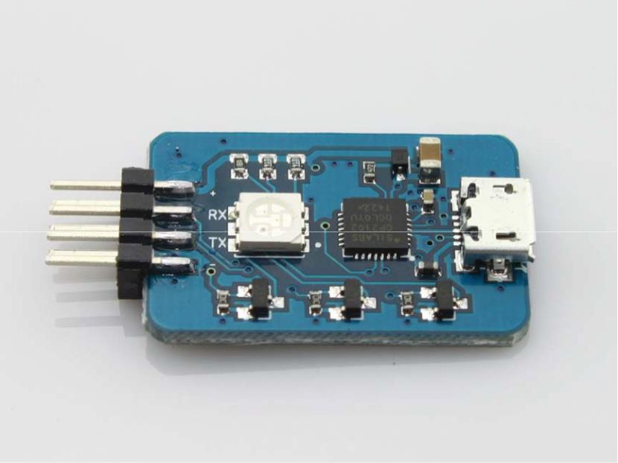

GPS Module

LED and link module

Product performance indicators

- Support manual mode, attitude mode, GPS mode.
- One key automatically return landing.
- Manual, attitude, GPS three working modes support headless mode.
- Electronic compass only involved in the GPS mode and headless mode. Reducing the crash risk after compass interference.
- During automatically return, can be shift to manual mode without dial any function key(switch).
- When the multi - rotor aircraft is out of control, optional choose automatic return or fixed hover. Need to set the remote control out of control to achieve these functions.
- Perfect support large paddle large aircraft frame, to meet the needs of users of large load machinery.
- Propeller rupture protection function supports only six-axis mode.

Aircraft technical parameter
Function | Description
Output | Electronic governor control frequency: 400HZ
Hover accuracy | Level: ± 2.5 m, vertical: ± 1 m
Max ail rudder angular velocity | 150°/S
Maximum tilt angle | 30°
Maximum lifting speed | 3.4m/s
Frame support | +4, X4, +6, X6, Y6
Operating system | Windows XP, Win7, Win8
Remote control requirements | At least 6 channels with “out of control” protection.  *Suggest two channels are three-stage switch channel.
Operating temperature | -10℃～50℃
Operating Voltage | 4.5~5.5V

M LITE 1/26/2015

www.3dpmav.com
- 5 -

M LITE 1/26/2015
JR/SPEKTRUM
AILE
A
CH1
E
CH2
ELEV
T
CH3
THRO
R
CH4
RUDD
X1
X2
AUX1
AUX2
AUX1
AUX2
Output port:
M1
M2
M3
M4
M5
M6
RADIO
OSD
www.3dpmav.com
- 6 -

M LITE master interface definition
Remote control please set to fixed wing mode, cancel mixing.
All fine-tuning are zero, the proportion of the channel settings are adjusted to the initial value is 100%.
Special attention should be paid to the installation of the rack, the place that master connected to the receiver is the front. The master has the side of the arrow faces up and maintains its level fixed to the center of the rack.
Aileron / roll
Lift / pitch
Accelerator
Direction / rotation Three-stage switch
Three-stage switch
Input port :

FUTABA/HITEC/etc.
No. 1 ESC, motor
No. 2 ESC, motor
No. 3 ESC, motor
No. 4 ESC, motor
No. 5 ESC, motor
No. 6 ESC, motor......etc.
Connect an external digital / Bluetooth module (for remote tuning and data telemetry)
Connect the external OSD module

M LITE 1/26/2015
LED
GPS
MAG
Connect the fly control board and LED module via LED cable
Connecter of the 5PIN for GPS wiring

Connecter of the 4PIN for GPS wiring

M LITE master
operating mode selection
The user needs two three-stage switches to select the flight mode. X1 selection: manual, posture, GPS three kinds of work mode formula. X2 for the corresponding mode of operation ON / OFF switch, headless mode, automatic return. Specific working mode can be connect to the computer computer or look at the signal module to do a careful confirmation of the signal.
X1
X2
LOW
MID
HIGH
LOW
MID
HIGH
LOW
MID
HIGH
Flight control working condition
Manual control mode, loose rocker body automatically restore horizontal state level.
Manual + headless
LOW
Attitude
MID
HIGH
Attitude + headless
Fixed height & fixed point
Fixed height & fixed point + headless
Automatic return
www.3dpmav.com
- 7 -

M LITE 1/26/2015
GPS Module
GPS integrated electronic compass. Please ensure that the direction of the arrow pointing to the direction of the nose, GPS antenna up. GPS module wires should be place away from the battery power lines, electrical and other interference if possible. In the outdoors, connect the computer with the host computer to detect the current gps module installation location is reasonable. After positioning to view the positioning accuracy of the host computer Hac, the optimal conditions can be positioning accuracy of 1 meter.
LED Module feedback lights
Red light
3 flash: GPS no positioning. 2 flash: General GPS signal. No red light: GPS positioning ok.
Green light
No green light: Manual mode. 2 flash: Attitude mode. 1 flash: GPS mode.
White light
Flashing: automatic return, static light: compass pointing due north.
All flashing RED
Low battery voltage alarm
Flashing yellow: compass is not corrected or compass interference, please land or switch to non-gps mode.
www.3dpmav.com
- 8 -

M LITE 1/26/2015
M LITE system installation
Brushless electronic governor throttle stroke correction
The following is a simple of a good surplus throttle stroke adjustment instructions, for the specific operation, according to their own use of the brushless electronic governor manual operation.
1. Turn on the remote control to hit the throttle to the highest point.
2. Connect the ESC to the battery for 2 seconds.
3. "Beep - beep -" throttle highest point confirmation tone.
4. Throw the throttle down for 1 second.
5. N short beeps indicate the number of lithium batteries.
6. "Beep -" throttle minimum point confirmation sound.
7. Push the throttle joystick motor to rotate smoothly and adjust the throttle stroke.
www.3dpmav.com
- 9 -

M LITE 1/26/2015
Multi - axis aircraft rack selection
Clockwise rotate motor with the Reversal paddle, the paddle has the letter R or P.
Counterclockwise rotate motor with the Positive paddle.
The arrow indicates the direction of the aircraft front plane.
www.3dpmav.com
- 10 -
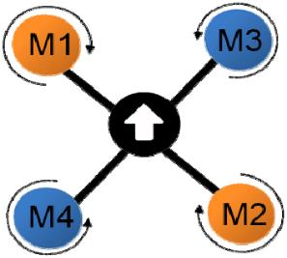

M LITE 1/26/2015
www.3dpmav.com
- 11 -
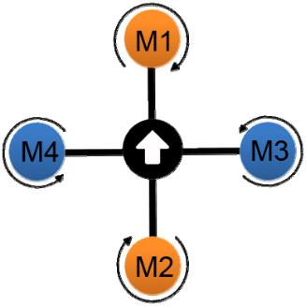
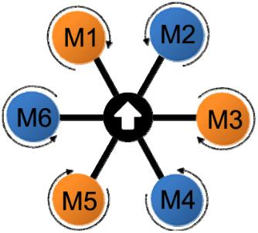

M LITE 1/26/2015
www.3dpmav.com
- 12 -
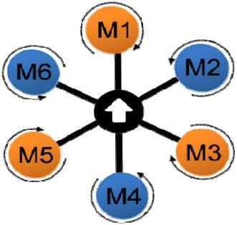
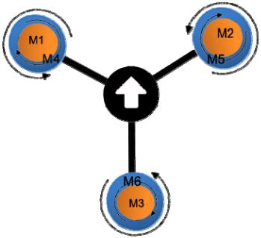

M LITE 1/26/2015
Upper propeller rotates clockwise, motor number: M1, M2, M3. Reversal Paddle,
paddle with letter R or P.
The lower propeller rotates counterclockwise, the motor number: M4, M5, M6. Positive paddle.
Receiver connection
Note: The flight control provides the 5V power supply to the receiver via the CH6 channel. CH6 MUST BE
connected to the receiver.
www.3dpmav.com
- 13 -

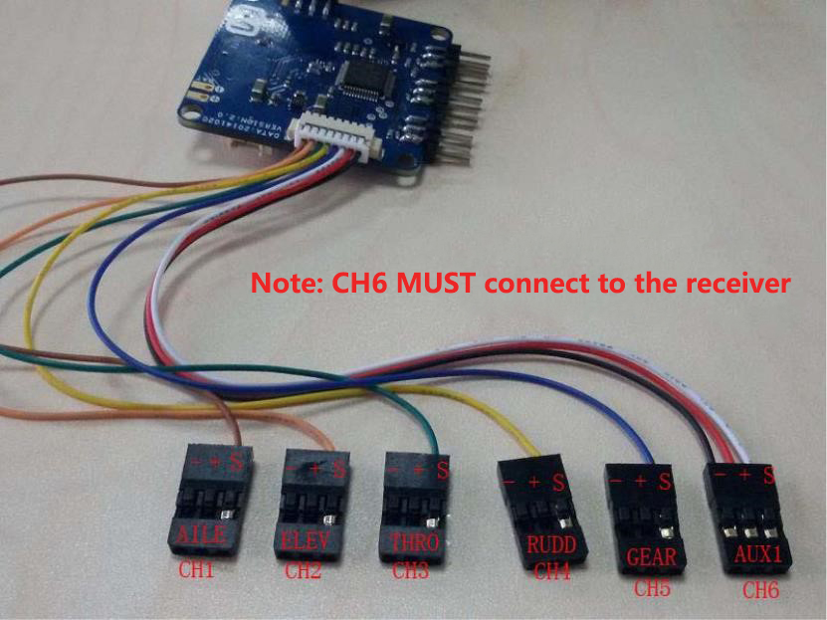

M LITE 1/26/2015
Positive and negative rudder settings
First time user or new remote control need to make the remote control joystick forward and reverse rudder settings to let the rocker stroke in correction operations.
CH1
AILE
CH2
CH3
CH4
ELEV
THRO
RUDD
JR/SPEKTRUM
NORMAL
NORMAL
NORMAL
NORMAL
FUTABA/HITEC/
REVERSE/
REVERSE/
REVERSE/
REVERSE/
M LITE PC parameter adjustment
www.3dpmav.com
- 14 -
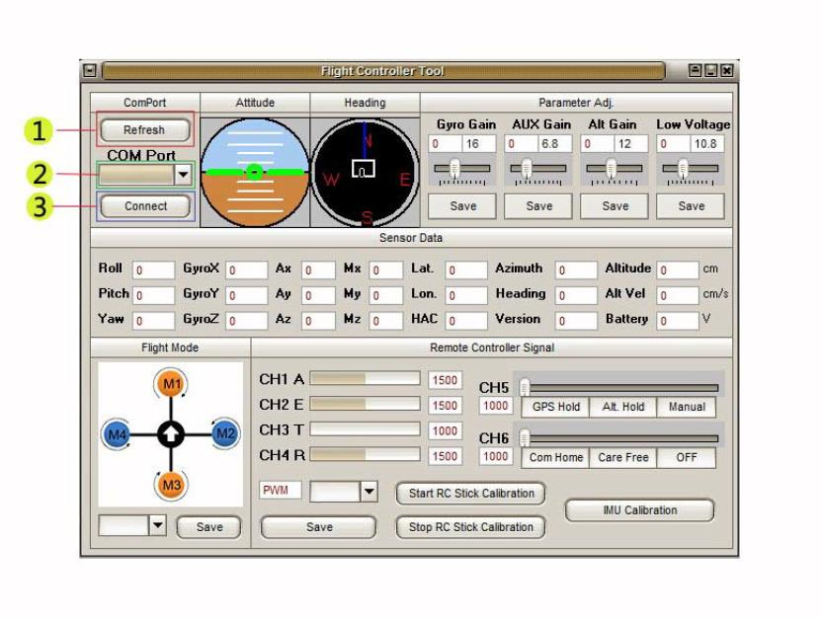

M LITE 1/26/2015
1.Connect usb cable to LED module usb socket, and the other plug in the computer.
2. Open the tuning software, click on the above ❶.
3. Click the ❷ down arrow, select the port. The port number can not exceed COM10. Please go to the hardware manager to find the serial port device to change the port number.
4. Click ❸ to connect. After connect success, data began to update.
www.3dpmav.com
- 15 -
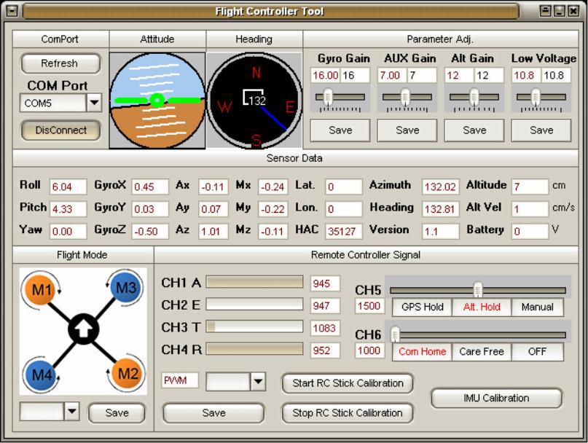

M LITE 1/26/2015

5. Click ❹to select the rack type and press save to save.
6. Click ❺ to enter the remote control stroke correction, blue light is on.
7. Push the joystick in the maximum working range to move 3 laps, back and forth toggle two three-stage switch 3 times.
8. Click the button ❻ to complete the rocker stroke correction (blue light is off).
9. After correction, the maximum and minimum values of the joystick and switch will in between 1000 to 2000. If more than 2000 or less than 1000, please recalibrate.
10. Keep the machine horizontally in place and click on Figure ❼ to start calibration level.
11. Click Disconnect again. Pull out the usb wire. Set up is done!
Note: Aileron, let joystick to the left, the corresponding software CH1, CH4 progress bar to the left; ailerons, let joystick to the right, CH1, CH4 progress bar to the right to move. Pitch, the throttle stick moves forward, CH2, CH3 progress bar moves to the right; pitch, the throttle joystick moves backward, CH2, CH3 progress bar moves to the left.
www.3dpmav.com
- 16 -
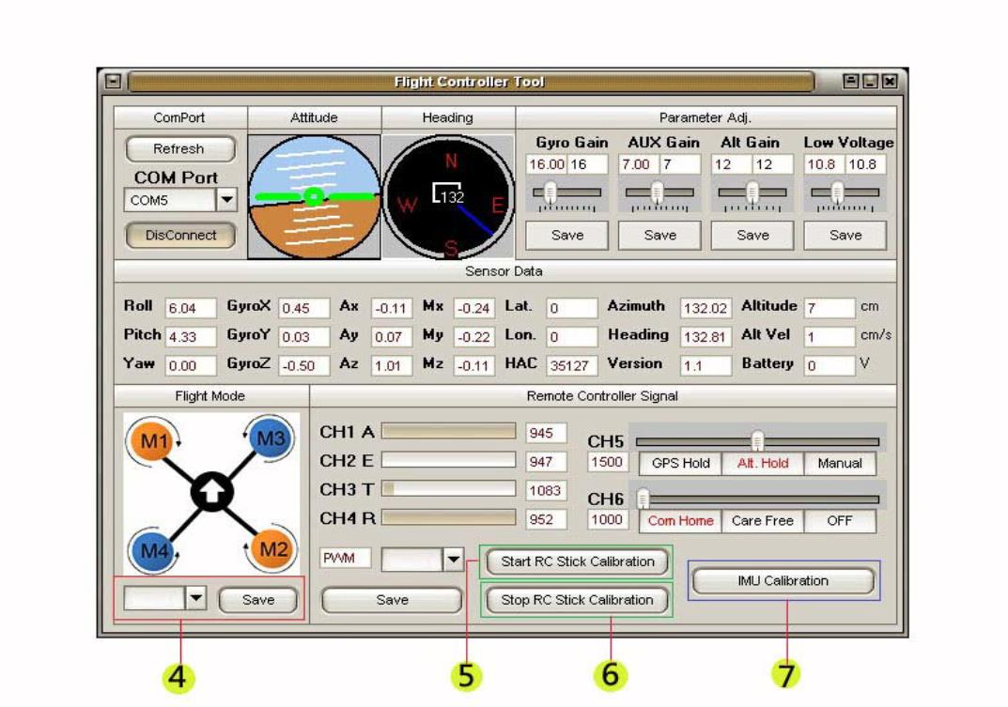

M LITE 1/26/2015
After rack and electronic equipment assembly
Check
Before the first power test, strong requirements that do not install the propeller to avoid accidents. Please check the flight control before powering on.
Check the polarity of the plug in order to avoid the polarity reverse resulting electronic equipment burned. After that, open the remote control power, then power on the machine.
First step to turn off the machine is the pull off the battery, and finally turn off the remote control. Do not make mistakes in order to avoid accidents.
Install the propeller
After confirming that the motor rotation direction meets the flight control requirements. Install the propeller by rack type. Clockwise arrows indicate the installation of clockwise rotation of the paddle, the blade on the text of an/a R or P. Counterclockwise arrows indicate the installation of counterclockwise paddle.
Please secure the propeller to the motor output shaft, so as to avoid flying in the process of flying propeller caused the aircraft overturned accident.
After installation, please confirm that the blade is installed correctly AGAIN. If there is a blade installation error will lead to take off after the machine rollover, horizontal spin and other failures. Take X4 as an example, head forward, upper left M1, lower right M2 motor and paddle clockwise rotation. Right upper M3, lower left M4 motor and paddle counterclockwise rotation.
Electronic compass correction
During correction please notice:
- Do not place in the room, strong magnetic field, underground reinforced structure, and around high voltage electricity tower.
- GPS can not be used near the north and south poles.
- The electronic compass on the rack should mount far from the power distribution board, the battery high current wire, and the power supply line as possible.
- Do not carry mobile phone, metal key ring and other magnetic materials before calibration compass.
- It is strongly recommended that a compass correction done before a new flight.
www.3dpmav.com
- 17 -

M LITE 1/26/2015
First turn on the remote control ,and power up the machine. You will see the indicator light is on. Rocker toward inside down, will get into the compass calibration process. Make your aircraft slow horizontal rotation at least three laps, during that, the blue light will flashing. Then turn three times to the right. Finally turn the machine three times forward.
The blue light is off after correcting process. Rocker toward outside down, will get out of the compass calibration process.
First time take off
Unlock the motor
Lock and stop the motor :
www.3dpmav.com
- 18 -
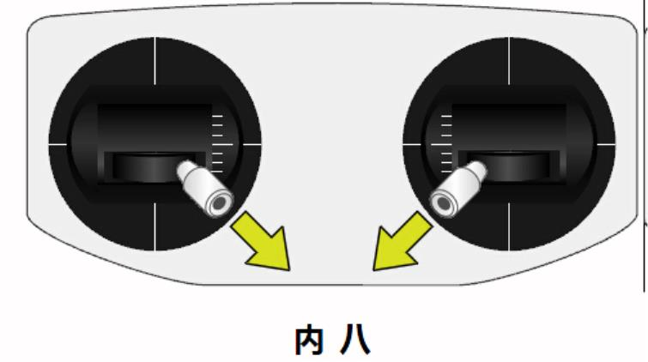

M LITE 1/26/2015
If indicator no red light, you must unlock the motor in GPS mode to set (lock) the home position, to enable a key return home function. When indicator light flashing green, the GPS mode can not lock home position (can not provide automatic return function) during flight. Automatic return on the way due to unexpected events such as the machine may have to encounter buildings, high voltage wire. This time does not require any function switch, manual operation of the remote control's joystick so let M LITE master immediately interrupt the automatic return.And let the user completely manually control the flight. After avoid the dangerous situation, if the function switch still select the automatic return mode, just release the joystick then the flight control will continue to return home from the current location.
www.3dpmav.com
- 19 -
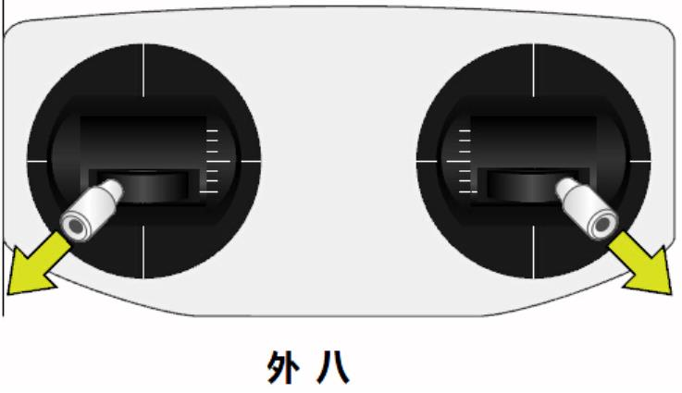

Lock and stop the motor :

GPS mode flight
HOME location
Note: In GPS mode to start automatically return, you must place the throttle in middle position, and then switch to the automatic return mode by control the switch to start the automatic return.

M LITE 1/26/2015
Out of control protection
Set out control protection according to your remote control. When the remote control is off, the receiver automatically outputs the signal to the flight control. So that flight control can be entered into the automatic return mode. Set the remote control pitch (lift), roll (aileron), throttle, direction (tail rudder) four channel rocker are centered. Flight mode (three stage switcher) to GPS mode. Function three-stage switcher switch to automatic return mode.
Firmware upgrade
Press the only button on the flight control and hold it, then use the usb cable to connect the flight control LED module and computer, give the flight control system power via computer usb port (please ensure that the computer USB interface power supply to meet the needs of flight control). Indicator lights flashing red, green and blue means that the flight control into the firmware upgrade mode so you can release the button. Open the firmware upload tool on your computer. Click open to find the upgrade with the firmware * .fcu file. Choose a COM port click connect. Start the firmware upgrade and the progress bar starts running. The final prompt show that the firmware upgrade is complete. Then click disconnect
to finish. After the firmware upgrade is complete, connect the tuning software to recalibrate the flight by the process above.
www.3dpmav.com
- 20 -

M LITE 1/26/2015
M LITE warranty terms
Warranty period start from the date of purchase.
1. Within 7 days, for the product quality problems, you can request a return or replacement. Product has 8 to 90 days free warranty. Seller / manufacturer not responsible for shipping cost.
2 . In one of the following circumstances, can not be treated as a warranty even in the warranty period. But can be implemented repair by charging fees:
Charge maintenance：
•Failure to use, maintenance, custody the product without manual require and damage caused;
• Due to improper operation, abnormal power supply, damaged (such as: fall, soaking, etc.) caused by damage;
www.3dpmav.com
- 21 -
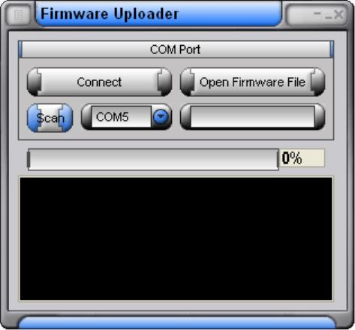

M LITE 1/26/2015
• Damage caused by personal disassembly;
• Damage due to force majeure (eg lightning, earthquake, fire, flood, etc.)
3. Paid Services. Warranty outside the flight control warranty.
• Paid services are subject to inspection, material, maintenance and transportation costs.
• If the product has been discontinued, the charges will be updated to the latest product. Will not repair.
www.3dpmav.com
- 22 -

